Stream Analysis V1

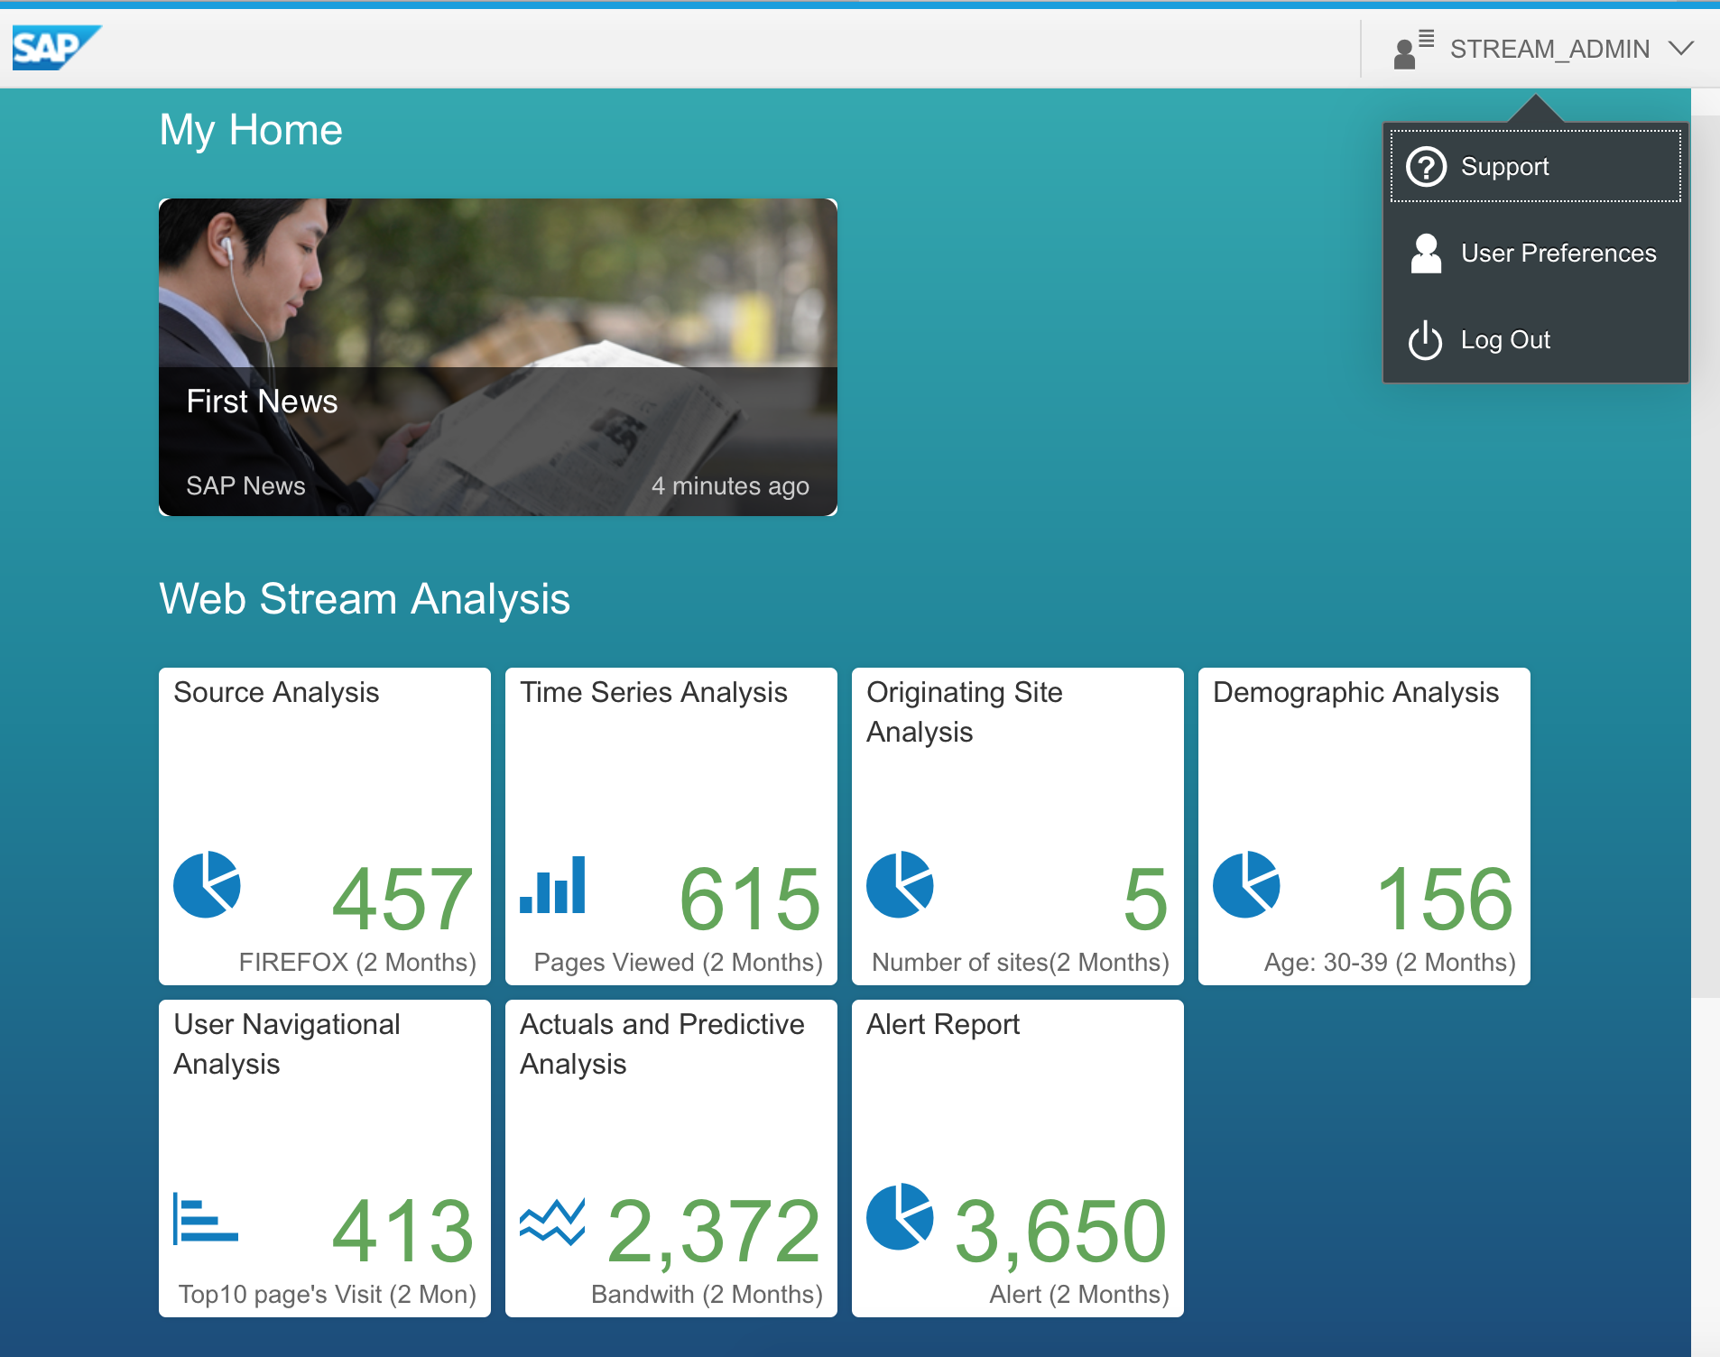

Stream Analysis V2

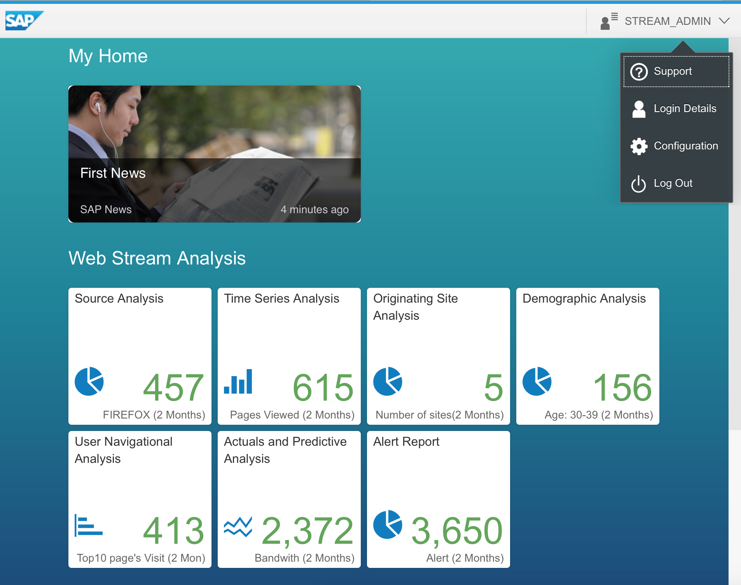

Navigation Dropdown Menu

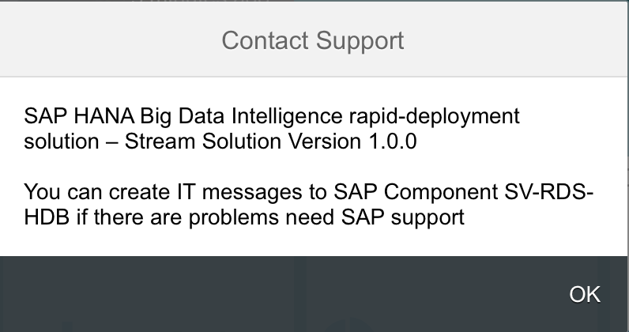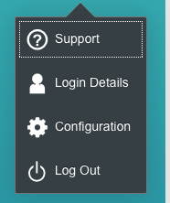

Version 2.0.0

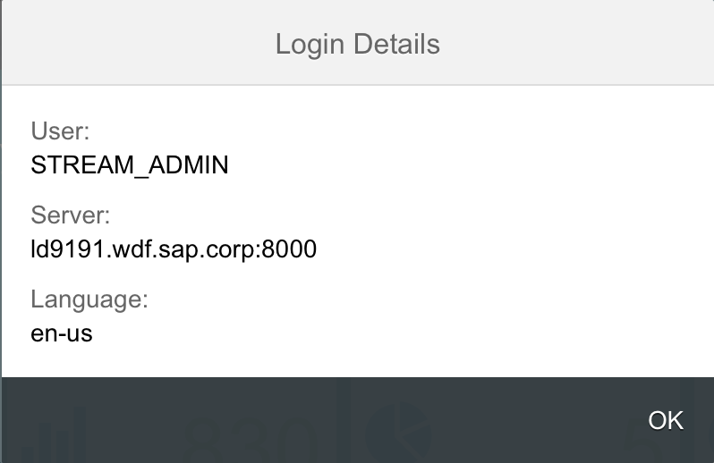

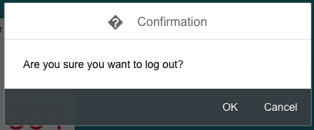 FYI Only ☺

"**Login**" is a noun; it shows a destination (*The login page*).

"**Log in**" is a verb, it shows an action. (*Log in to your account*).

Configuration Page - Icons and Buttons Details

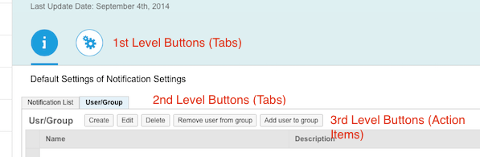

* First Level of Buttons (SAP UI5 etc) -
  +  - Information display (not Editable)
  +  - Settings – Editable values were you can change the parameter values accordingly,
    - Is there a Save button? or are the changes saved automatically?
* 2nd Level Tabs – use the round Icons
  +  Notification List – (list icon)
  +  User/Group - (Group icon)
  +  General - (Action Settings icon)
* 3rd Level – Actionable items:
  +  Create
  +  Edit
  + Delete
  +   Deactivate - (Status-negative icon)
  +  Add (Term) to Group - (Folder icon)
  +  Remove user form Group - (Employee–rejections icon)
  +  Add user to Group - (Employee-approvals icon)

General Settings:

News Feed option to have it dispaly with link or not to display

**Note: Sipingsoft… this is just an idea of the settings we need for this page, it does not have to be exactly like this, use what is standard and make changes accordingly

